Analytical Queries

Window Functions & Analytical Functions

Whenever we want to see pure summary outputs like department number wise highest salaries then we use the Group By technique and aggregate function. But the Group By clause can only give you pure summary result. It is not capable of showing summary values along with actual records.

What if we want to show the employee name, salary, that employee’s department’s highest salary for each record? Group by fails in that case. In such a scenario Window Ranking, Offset, and Aggregate Functions will help us!!

Though analytic functions like Over() give aggregate result they do not group the result set. They return the group value multiple times with each record. As such any other non-"group by" column or expression can be present in the select clause.
Partition by will do aggregation and display it for all the records (After aggregating the value grouping is not done)

Over () clause

If OVER( ) function is NOT having any parameters the function acts on entire record set returned by the where clause.

select ename, job, max(sal) over () "Highest Salary" from emp

(The max(sal) value is repeated for all the rows)

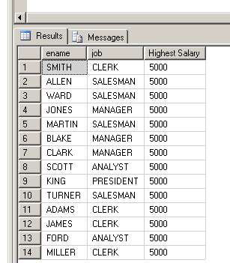

What Over() Clause does?

Over() clause creates a specific window, i.e. user defined set of rows provided by the select statement.

Then after creating the window of those rows, it further computes a value for each row in that result set. Now that computation can be any aggregate function like min, max, sum, running totals, moving averages, etc. or that computation can be generating auto numbering, generating ranks based on data values.

Finally the computed value is given to each row within that set.

A scalar function such as NVL, Case, Cast cannot be given before Over function.

select ename, job, NVL(Comm,0) Over () "Comm" from emp

Error Message The function 'NVL' is not a valid windowing function, and cannot be used with the OVER clause.
To perform calculations with aggregate values and actual values

To see the difference in the max(sal) and sal for each employee.

select ename, job, max(sal) over () "Highest Salary", sal "Actual Salary",
(max(sal) over() – sal) "Difference"
from emp

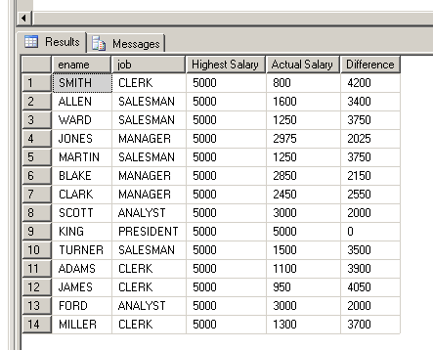

Over (Partition by) clause

To see name, job, salary and maximum salary within each job.

select ename, job, sal,
max(sal) over (partition by job) "Job Wise Max Sal"
from emp

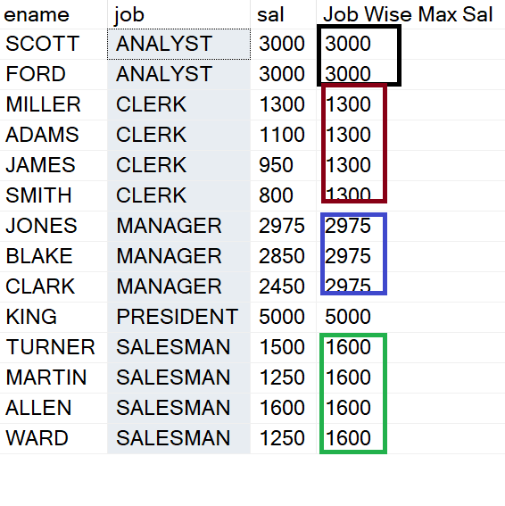

Partition By Clause: The Partition By clause will sort the rows mentioned as per that column (s) and then do the aggregation, ranking as per the distinct values of that column.

Example of wrong column in Partition By:

If a column having unique values is given in the Partition by clause then it will result in logically wrong output.

select ename, job,
max(sal) over (partition by ename) "Ename Wise Max Sal"
from emp -- Logically Wrong, although no error is given

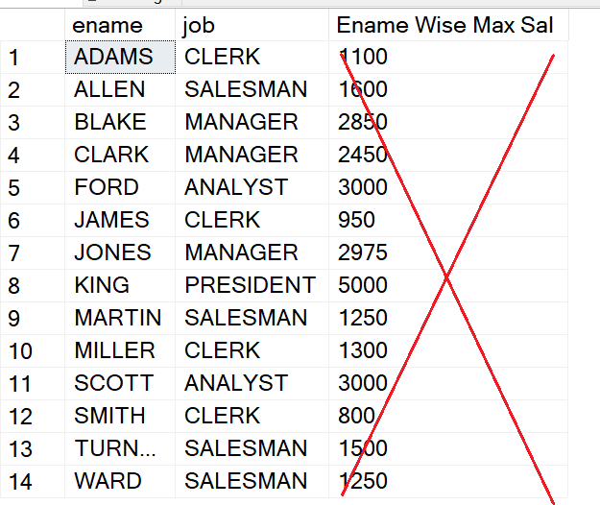

Multiple Columns in Partition By Clause

Select Trans_id, Continent, Country,
Sum(Sales) Over(Partition By Continent, Country) as "Total Sales"
from Products2

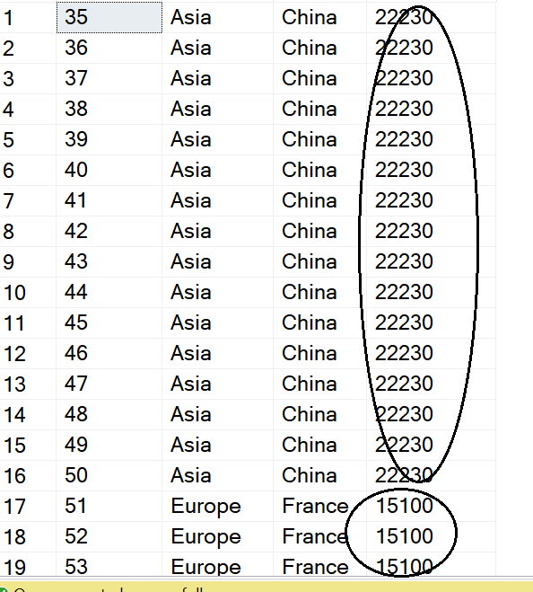
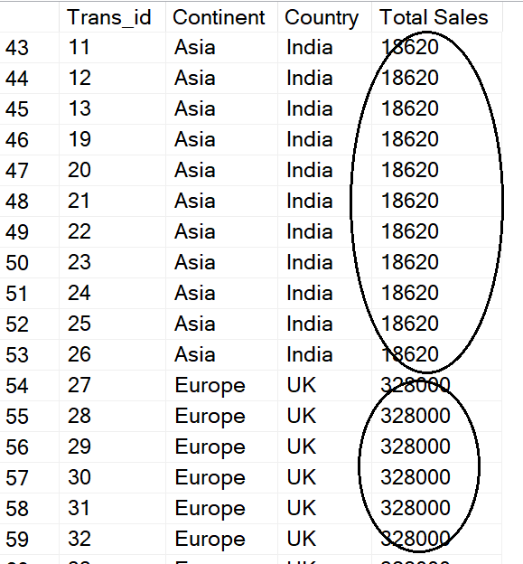

If the column used in Partition by clause has null values then for all those nulls it will do the sorting and aggregation.

Update emp
set job = null
where job = 'CLERK'

select * from emp

select ename, job,
max(sal) over(partition by job) "Job Wise Max Sal"
from emp

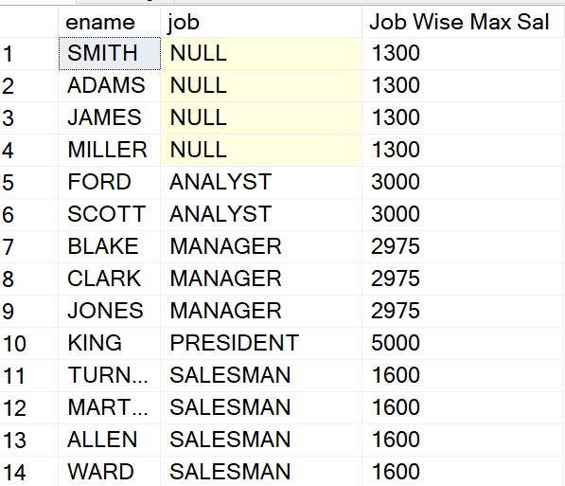

Let’s restore the default values in the emp table.

Update emp
set job = 'CLERK'
where job is null
Partitioning on Expression Values:

Especially suitable for date value analysis.

select ename, to_char(Hiredate, 'yyyy')) as "Year of Joining",
max(sal) over (partition by to_char(Hiredate, 'yyyy')) "Year wise Max Sal"
from emp

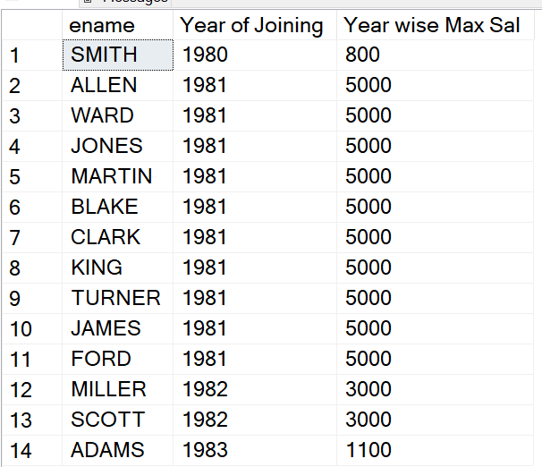
Ranking Functions

RANK and DENSE_RANK both provide rank to the records based on some column value or expression. In case of a tie of 2 records at position N, RANK declares 2 positions N and skips position N+1 and gives position N+2 to the next record. While DENSE_RANK declares 2 positions N but does not skip position N+1.

Rank()

select ename, sal, Rank() over(order by sal desc) from emp

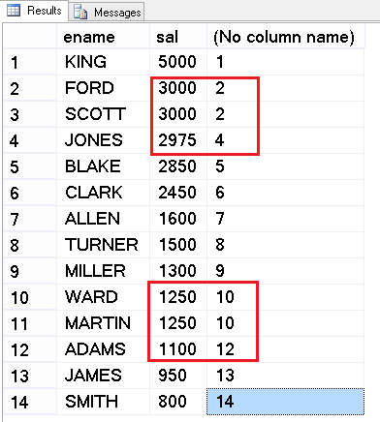

In Rank function in case of ties the next value will get the physical row number and not the logical row number.

Dense_Rank()

select ename, sal, Dense_Rank() over(order by sal desc) from emp

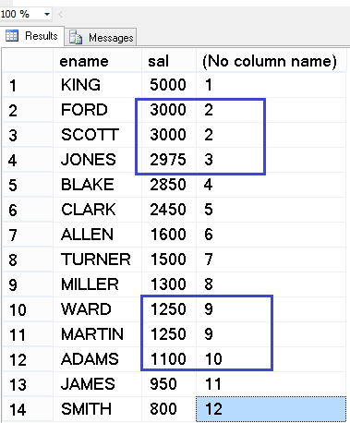

In Dense_Rank function in case of ties the next value will get the logical row number and not the physical row number.

Example of Order By in Over() function and at the end of Select Statement:

select ename, sal, Dense_Rank() over(order by sal desc) as "Salary Rank" -- Order By inside Over() is used for ranking
from emp
Order by ename -- The Order by at the end is for sorting the result ename wise A to Z

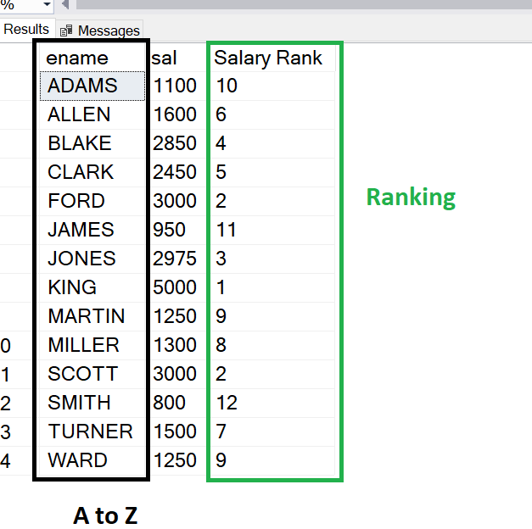

Ranking along with Partition By:

select ename,
sal,
deptno,
dense_rank() over(partition by deptno order by sal desc) "Salary Rank as Deptno"
from emp
order by 3,4

ENAME SAL DEPTNO Salary Rank as Deptno
---------- ---------- ---------- -----------------------
KING 5000 10 1
CLARK 2450 10 2
MILLER 1300 10 3
SCOTT 3000 20 1
FORD 3000 20 1
JONES 2975 20 2
ADAMS 1100 20 3
SMITH 800 20 4
BLAKE 2850 30 1
ALLEN 1600 30 2
TURNER 1500 30 3
WARD 1250 30 4
MARTIN 1250 30 4
JAMES 950 30 5

For DEPTNO 20 there are two contenders for the first position Scott and Ford. So it has given the same number 1 for those and directly given rank number 2 for Jones of the same deptno 20.
Same case is for last 3 records of deptno 30.

Nulls Values in Ranking:

update emp
set sal = null
where ename = 'SMITH';

update emp
set sal = null
where ename = 'KING';

select ename, sal, Dense_Rank() over(order by sal desc) from emp --?????

select ename, sal, Dense_Rank() over(order by sal) from emp --?????????
Row_Number()

It will provide the row numbers for the result set once the records are sorted.

Order By is the mandatory clause required for row_number().

select ename, row_number() over(order by ename) from emp

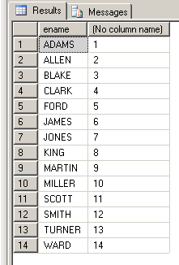

select ename, sal, row_number() over(order by sal desc) from emp

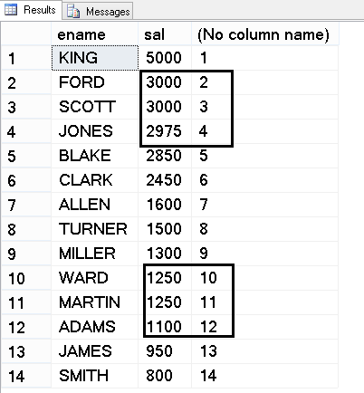

Even if there is tie (same values) RowNumber() will always give the next serial number only.
So RowNumber() gives us True serial or auto number independent of tied values.

As a best practice RowNumber() column should be ideally the first column in Reports.

select row_number() over(order by ename) as "RowNumber",
ename,
Sal,
Deptno,
Job
from emp;

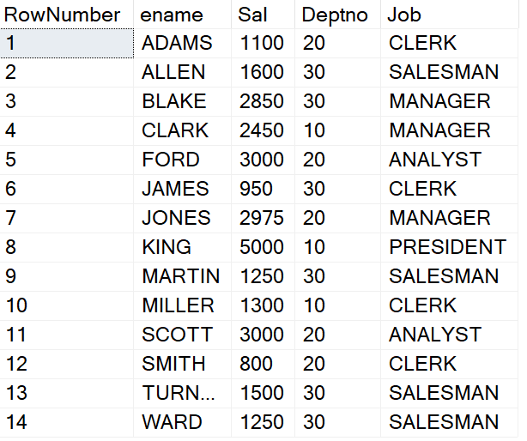

RowNumber() function along with Partition By clause:

select row_number() over(Partition by deptno order by ename) as "Number in Deptno",
ename,
Sal,
Deptno
from emp;

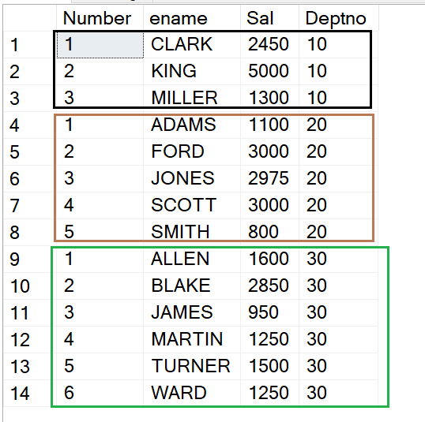

In the above example the row numbers are within the current Deptno values.

Example of Physical Row Number of Record and row number within deptno

select
row_number() over(order by deptno) as"Physical Row Number",
row_number() over(Partition by deptno order by ename) as "Number in Deptno",
ename,
Sal,
Deptno
from emp

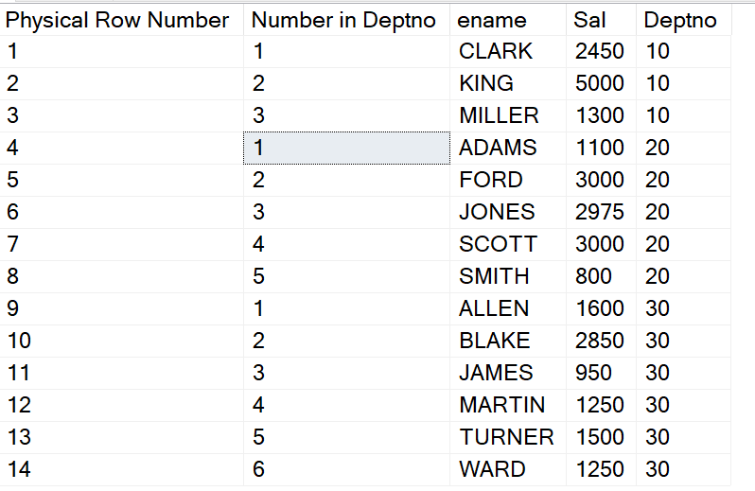
The Windowed Functions cannot be used in the where clause.

To get the records of top 3 earners:

select ename, sal,
Dense_Rank() Over(Order by Sal desc) as Salary_Rank
from emp
where Dense_Rank() Over(Order by Sal desc) <= 3
x`

Error Message ORA-30483: window functions are not allowed here

select ename, row_number() over(order by ename)
from emp
where row_number() over(order by ename) <= 5

Same Error Message ORA-30483: window functions are not allowed here

What is the Solution??????????????

Solution is using either a CTE or a Derived Table!!!
Top – N Analysis becomes very easy using the Windowing and Ranking functions.

To show records of top 3 salary earners.

With CTE as
(select ename, sal,
Dense_Rank() Over(Order by Sal desc) as Salary_Rank
from emp)
Select *
From CTE
where Salary_Rank <= 3

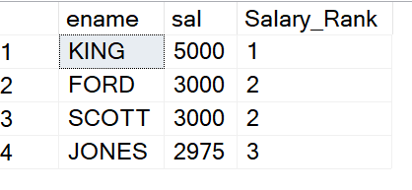

Or by Inline Views or Derived Table

Select *
From (select ename, sal,
Dense_Rank() Over(Order by Sal desc) as Salary_Rank
from emp)
where Salary_Rank <= 3;

To show the 2nd highest earner record within each department number.

With Employee_Ranking as
(select ename, deptno, sal,
Dense_Rank() Over(Partition by Deptno Order by Sal desc) as Salary_Rank
from emp)
Select *
From Employee_Ranking
where Salary_Rank = 2

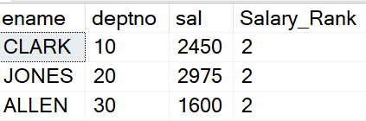

To see names, salaries, job, average salary and difference (raise) with average salary of those employees who earn more than the average salary in their jobs.

With Employees as
(select ename, job, sal,
Avg(Sal) Over(Partition by job) as Average_Salary
from emp)
select ename,
sal,
job,
Average_Salary,
(Sal - Average_Salary) as "Raised"
From Employees
where Sal > Average_Salary

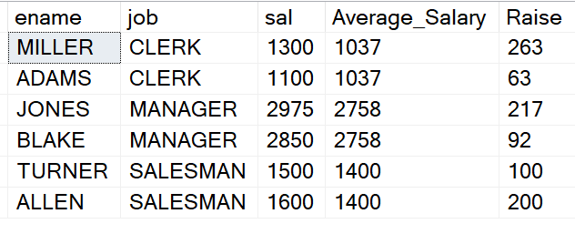

Views and Window Functions:

Generally, in the projects the complex select statement used along with Window functions are put inside a View.
User will query the view simply be mentioning just ….
select * from viewname

create view Employees_Above_Average_Salary
as
select deptno,ename, job, sal, Average_Salary, Sal - Average_Salary as "Raise"
From (select deptno, ename, job, sal,
Avg(Sal) Over(Partition by job) as Average_Salary
from emp) as DT
where Sal > Average_Salary

Later we will just query the view:

select * from Employees_Above_Average_Salary

Further customization in output also becomes easy:

select * from Employees_Above_Average_Salary
where Average_Salary > 2000

Such Views are also good when we want to further join that result with some other table.

Select D.*, V.Ename, V.Job,V.Sal, V.Average_Salary, V.Raise
from Employees_Above_Average_Salary V Join Dept D
On V.Deptno =D.Deptno

Getting Running totals or also known as Cumulative Totals:

Use rows between unbounded preceding and current row to get running totals!

Select Empno, Ename, Sal,
Sum(Sal) over (order by Empno rows between unbounded preceding and current row) as "Running total"
from emp

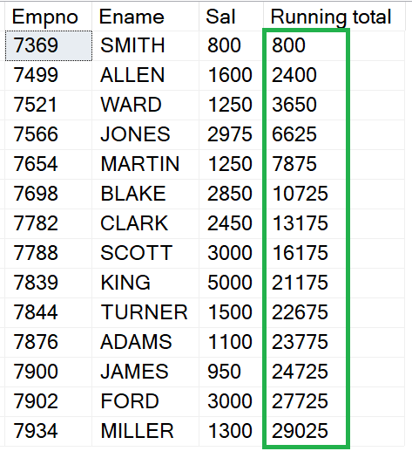

In the above example the rows were sorted as per empno and then running total was done.

In the next example sorting will be done as per sal low to high and then running total will be done.

Select Empno, Ename, Sal,
Sum(Sal) over (Order by Sal rows between unbounded preceding and current row) as "Running total"
from emp

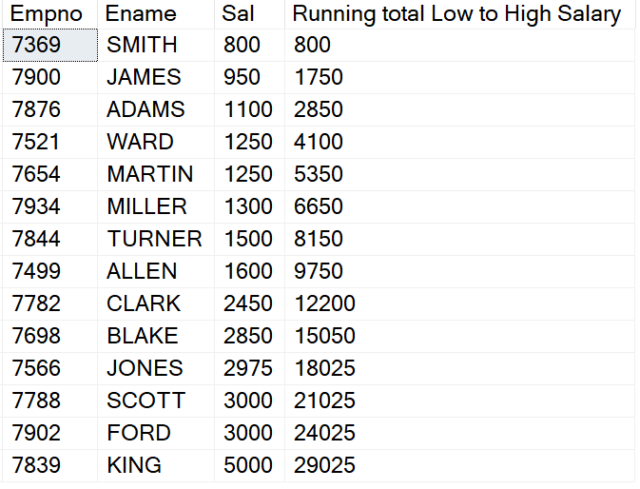

Running Totals within each Deptno

Select Empno, Ename, Sal,Deptno,
Sum(Sal) over (Partition by Deptno order by Empno rows between unbounded preceding and current row) as "Running total in Deptno"
from emp

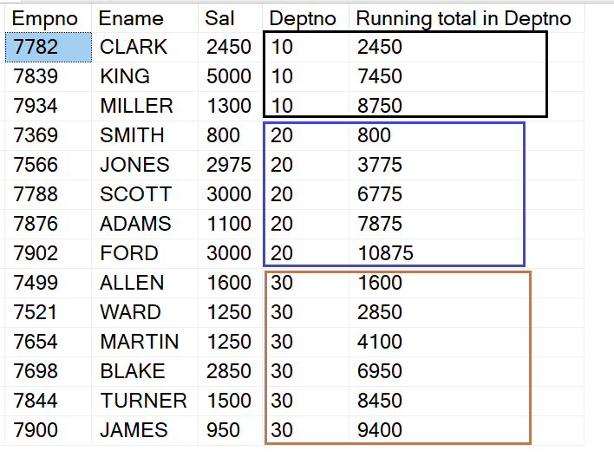

Running totals as per specific rows preceding instead of unbounded:

Select Empno, Ename, Sal,
Sum(Sal) over (order by Empno rows between 2 preceding and current row) as "Running total"
from emp

It means total of current row’ salary and the last 2 rows salary.

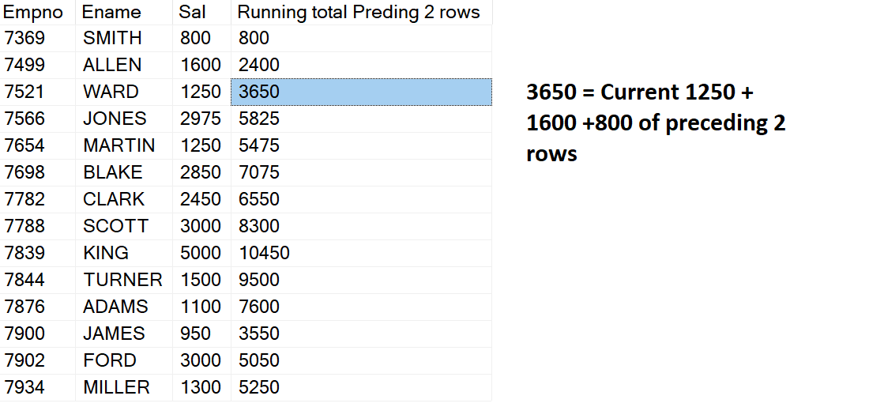
Lead Function:

Lead Function without 3rd parameter
--LEAD(return_value ,offset[,default value for first or last])
The following function shows the next empno number in the current row.
On the last row since the 3rd parameter is not mentioned it returns NULL

Select empno, ename, job, deptno, sal,
Lead(empno,1) Over (Order by empno) as "Next Employee ID"
From Emp

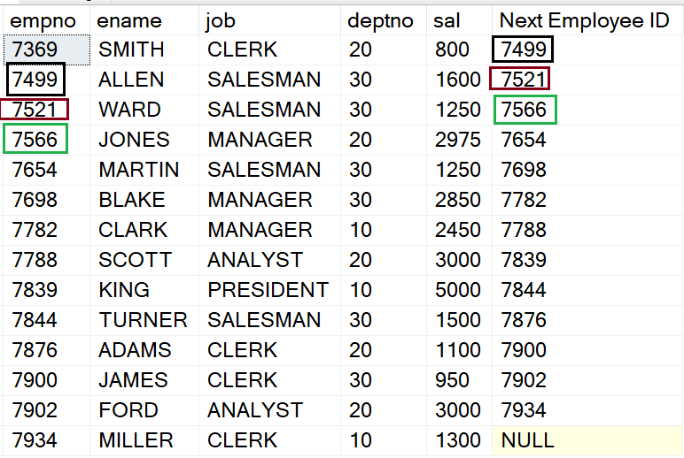

By default, if the 3rd parameter is not given then it shows Null for the last record.

Mentioning the 3rd parameter, i.e. default value for last record.

Select empno, ename, job, deptno, sal,
Lead(empno,1,0) Over (Order by empno) as "Next Employee ID"
From Emp

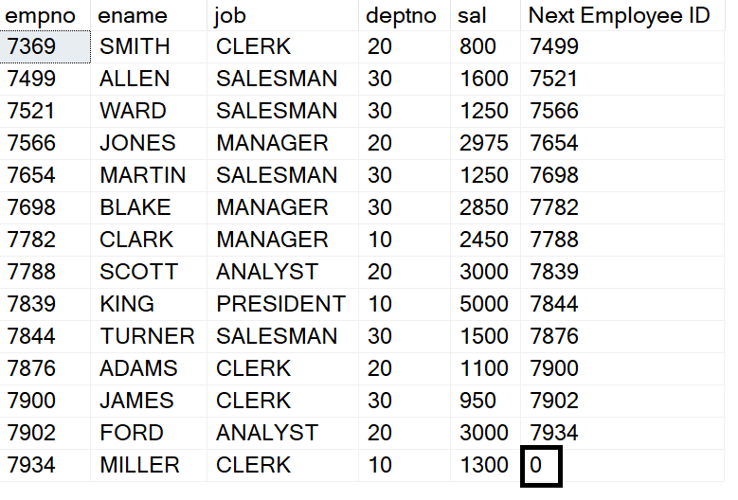

To mention some text as N/A for the last value type cast it into string using cast function.

Select empno, ename, job, deptno, sal,
Lead(to_char(empno),1,'N/A') Over (Order by empno) as "Next Employee ID"
From Emp

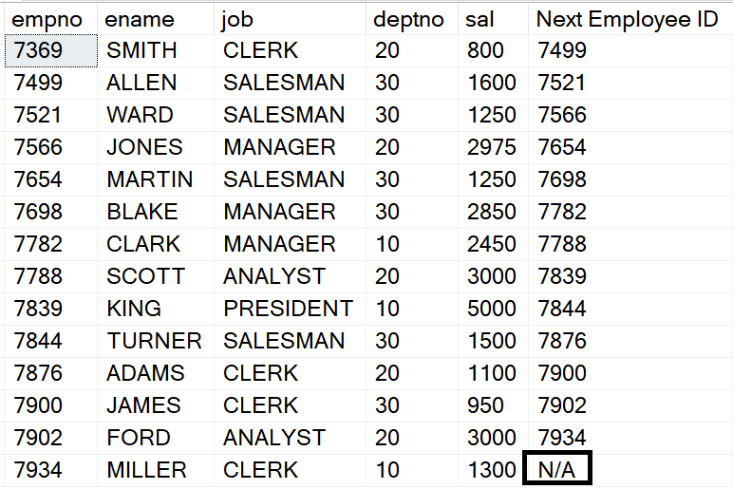
The Lead Column and the internal Order by column can be same also.

Select empno, ename, job, deptno, sal,
Lead(to_char(sal),1,'Already on Last') Over (Order by Sal) as "Next Salary"
From Emp

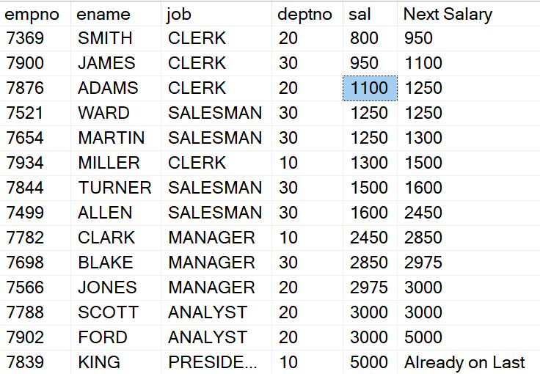

More user-friendly output will be showing the next value as employee name rather than empno. Note in the Order by clause there may be empno or ename.

Select empno, ename, job, deptno, sal,
Lead(ename,1) Over (Order by empno) as "Next Employee"
From Emp

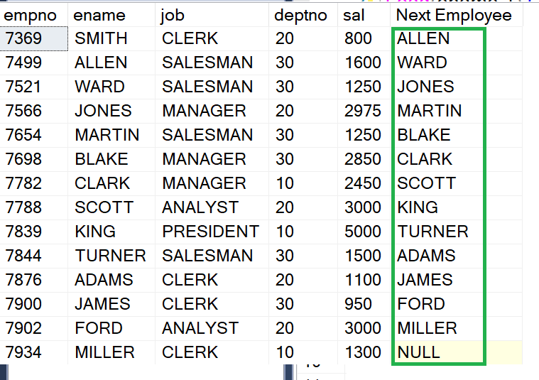

Offset value can be greater than 1 as well.

Select empno, ename, job, deptno, sal,
Lead(ename,2) Over (Order by empno) as "Next to Next Employee"
From Emp

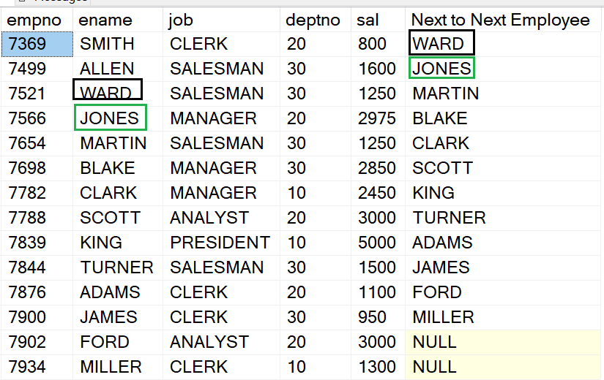

By default, the Offset value if not mentioned is always 1.

Select empno, ename, job, deptno, sal,
Lead(ename) Over (Order by empno) as "Next to Next Employee"
From Emp

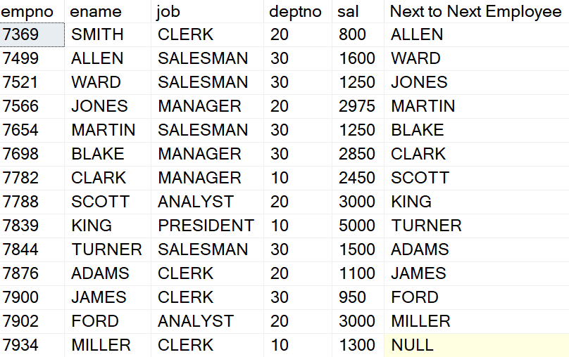

Lead Function along with Partition By Clause:

The following function shows next ename within each deptno.
Once the deptno gets changed the same process will be shown for all enames within that Deptno.

Select ename, deptno, sal,
Lead(Ename,1,'') over (Partition by Deptno
Order by Ename ) as "Next Employee within Deptno"
from Emp

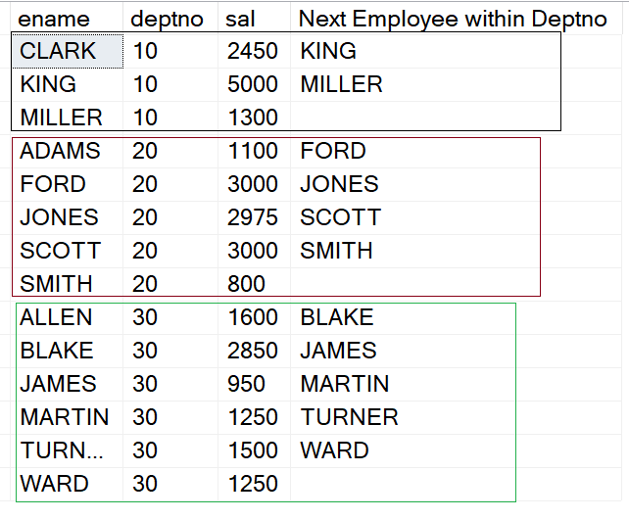

Lag Function:

Lag Function without 3rd parameter
--LEAD(return_value ,offset)
The following function shows the previous empno number in the current row.
On the first row since the 3rd parameter is not mentioned it returns NULL

Select empno, ename, job, deptno, sal,
Lag(ename,1) Over (Order by empno) as "Previous Employee"
From Emp

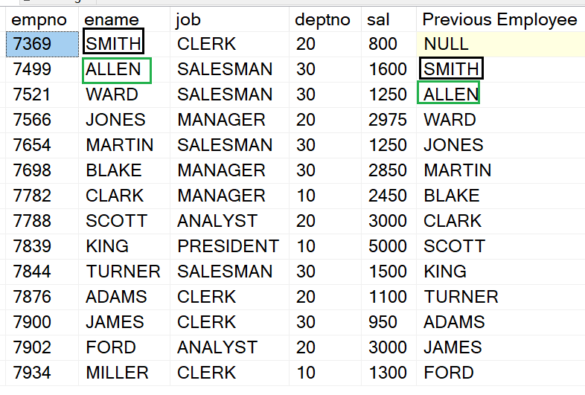

Mentioning the 3rd parameter, i.e. default value for first record

Select ename, job, deptno, sal,
Lag(ename,1,'N/A') Over (Order by ename) as "Previous Employee"
From Emp

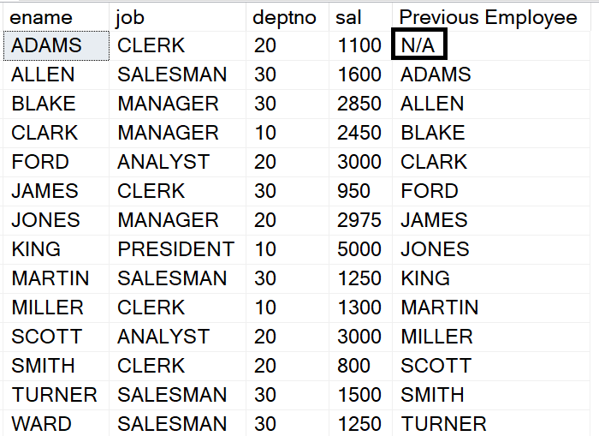

Lag Function along with Partition By Clause:

The following function shows previous ename within each deptno.
Once the deptno gets changed the same process will be shown for all enames within that Deptno.

Select ename, deptno, sal,
Lag(Ename,1,'') over (Partition by Deptno
Order by Ename ) as "Prev Employee"
from Emp

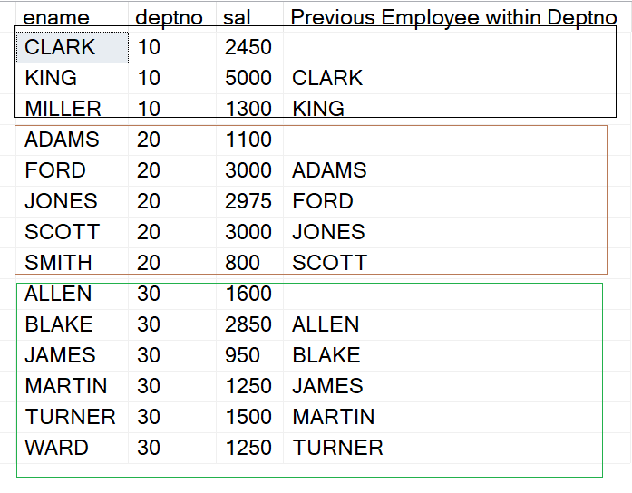

First_Value function:

Returns the first value in the current window frame. Requires window ordering to be meaningful.
The following example shows the first employee name for each row!!

Select ename, job, sal,
First_Value(ename) Over (Order by empno) as "First Person"
From Emp

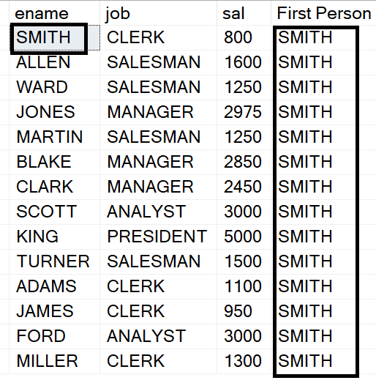

First_Value function along with Partition By clause:

Select ename, job, sal,
First_Value(ename) Over (Partition By Job Order by empno) as "First Person in Job"
From Emp

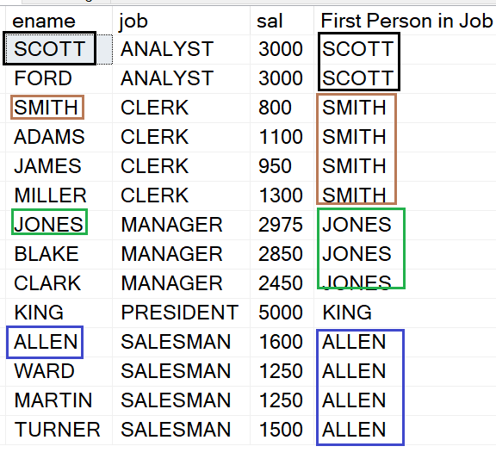

Last_Value Function:

Returns the last value in the current window frame. Requires window ordering to be meaningful.
The following example shows the last person's name for each row.
Note: In case of Last_Value function if the Order By clause has a unique value column then it does not make any change.
We need to use a column which has repeating values in the Order by clause.
This is only necessary for Last_Value function.
For First_Value function this care is not required.

Select ename, job, sal,
Last_Value(ename) Over (Order by Job) as "Last Person in Job"
From Emp

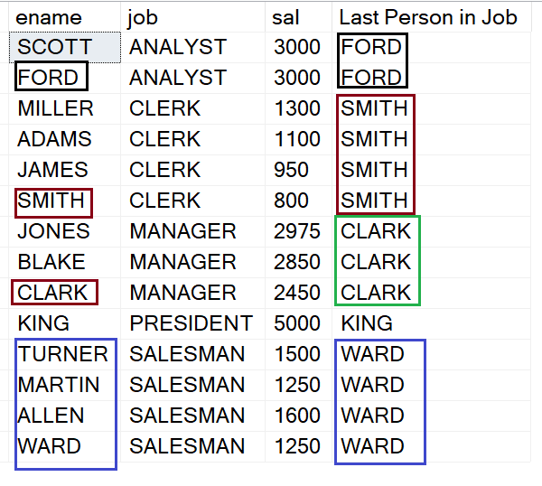

If in Order By clause a column having unique values is given then it does not work properly.

Select ename, job, sal,
Last_Value(ename) Over (Order by Empno) as "Last Person"
From Emp

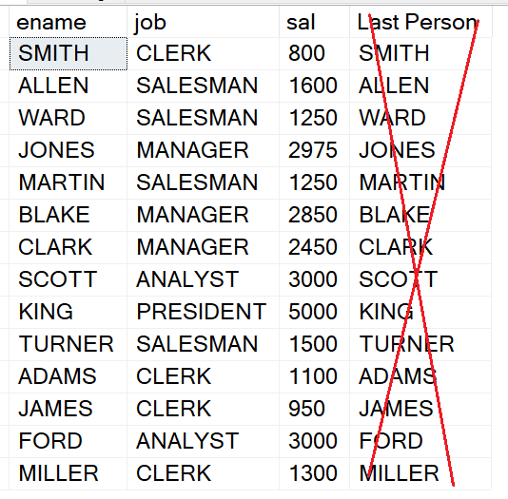

Last_Value function along with Partition By clause:

Actually, there is no need to use Partition by clause when Last_Value is the function. Because in Order by clause if we are taking care of using a column having repeating values then that column itself acts as Partition by column.

Select ename, job, sal,deptno,
Last_Value(ename) Over (Partition By Deptno Order by Deptno) as "Last Person in Deptno"
From Emp

OR

Select ename, job, sal,deptno,
Last_Value(ename) Over (Order by Deptno) as "Last Person in Deptno"
From Emp

Output for the above 2 select statements is same as shown next

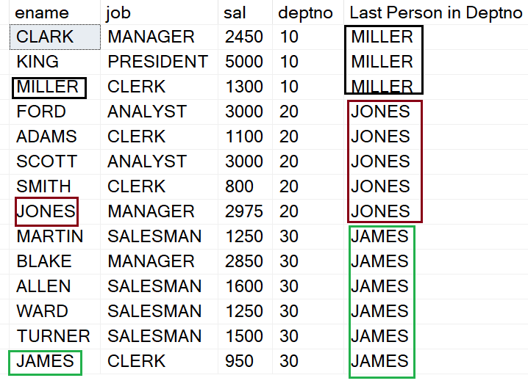

Note If the Partition By and Order By columns are different then the output will be inconsistent.

Percent_Rank Function:

The PERCENT_RANK function in SQL Server calculates the relative rank Percentile of each row. It always returns values greater than 0, and the highest value is 1 (Or up to 1, i.e. not exact 1), lowest being 0.

Note PERCENT_RANK is similar to the CUME_DIST function. CUME_DIST calculates the relative position of a specified value in a group of values.

Select empno, ename, sal,
Percent_Rank() Over(Order by Sal) as "Percent Rank"
from Emp

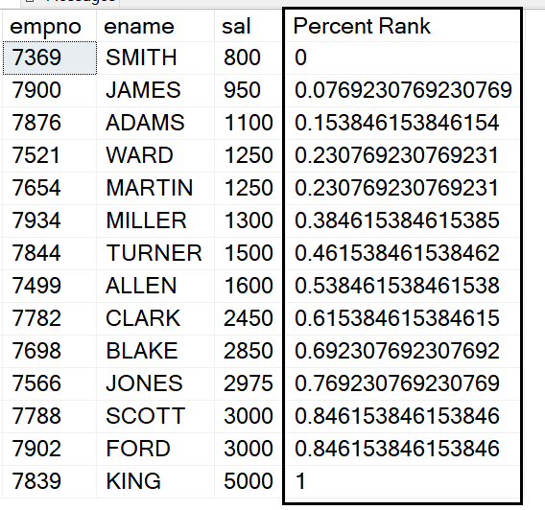

Percent_Rank with a column having Null values.
It does not count any NULL values.

Select empno, ename, Comm,
Percent_Rank() Over(Order by Comm) as "Percent Rank"
from Emp

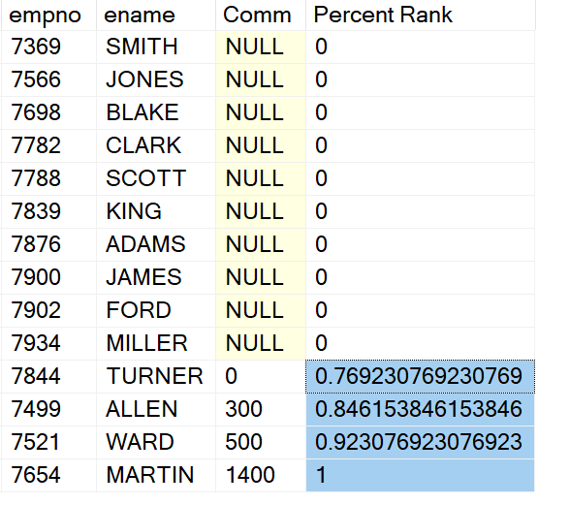

Percent_Rank Function along with Partition By Clause:

Select empno, ename, deptno, sal,
Percent_Rank() Over(Partition by deptno Order by Sal) as "Percent Rank"
from Emp

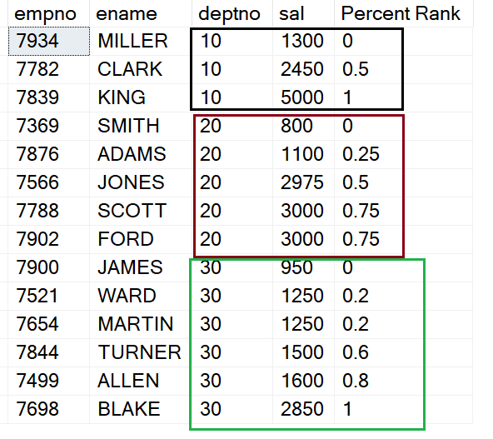

NTile Function:

Distributes the rows in an ordered partition into a specified number of groups. Returns the number of the group to which the current row belongs.

Select Empno, Ename, Job,
NTile(3) over(Order by Empno) "Group Number As Per Entire Table"
from Emp

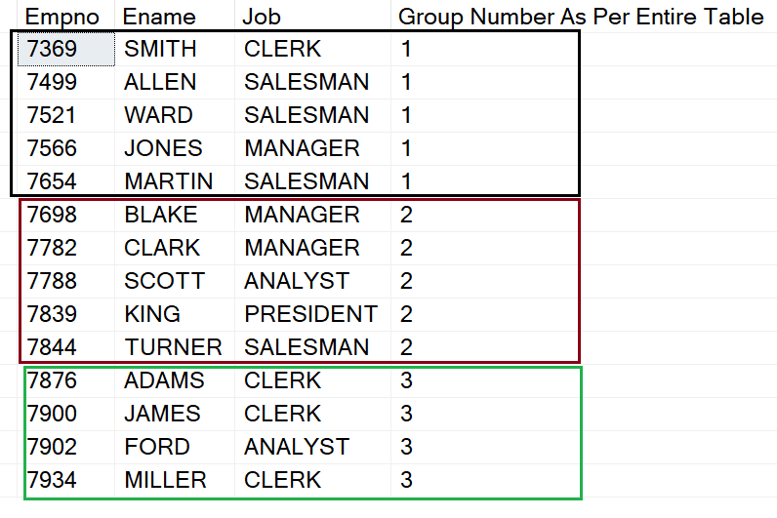

In the above example there are totally 14 rows. Since the group of 3 is mentioned so 14 / 3 means 4.66 rows, i.e. rounding to 5 rows will come in first group. It will give 1 as the group number to that group.
Then the next 5 rows will come in the next group. It will give 2 as the group number to that group, and like this it will continue further. And finally, less balance number of rows in the last group.

NTile Function along with Partition By Clause:

select trans_id, continent, country, sales,
NTile(10) Over(Partition by Continent Order by trans_id) as "Group Number in Continent"
from products2

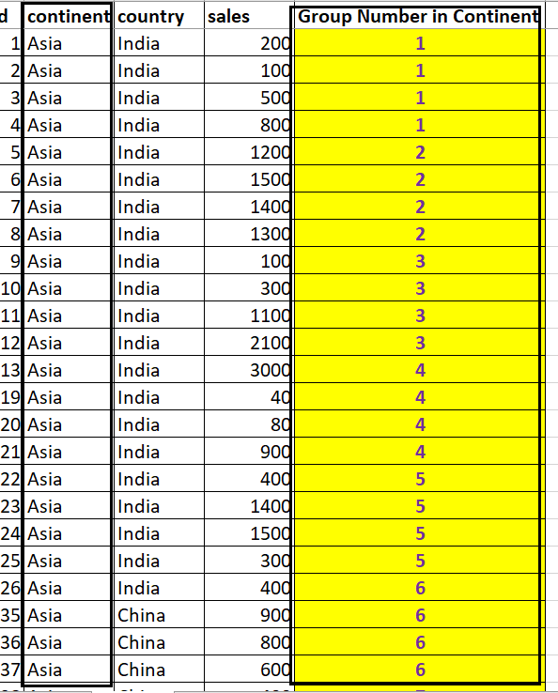

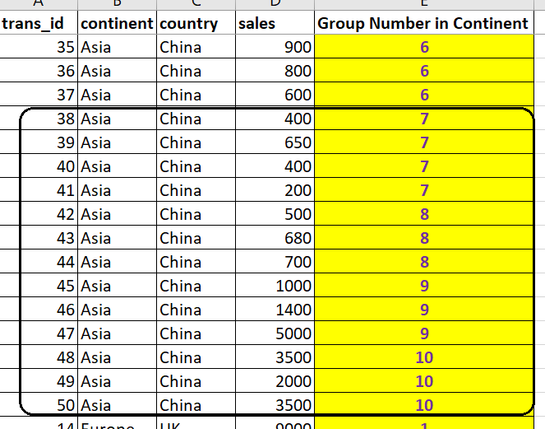

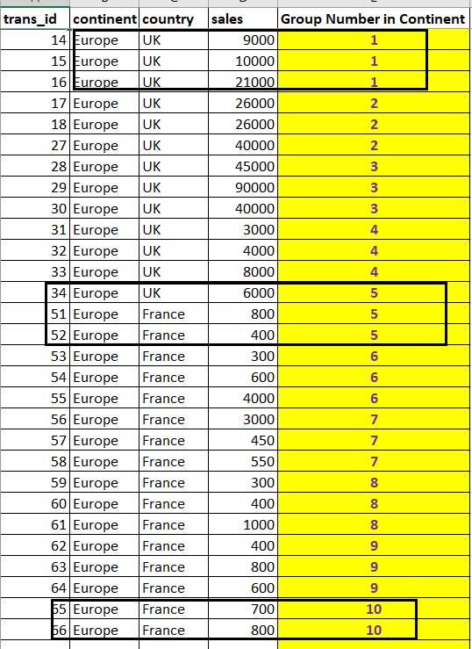

Explanation:

In the above example Partition by Continent is mentioned. So it will see how many rows are there in each continent.

For clarity internally it will get the number of rows per continent by following query:

Select Continent, Count(*) as "Number of Rows"
from Products2
Group by Continent

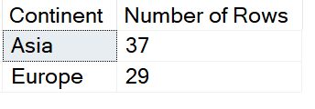

So, of Asia’s total 37 rows. It will form group of 10 rows in each group. That means 37 / 10 = 3.7, so rounding it off to 4 rows in each group of Asia and less balance number of rows in the last group.

Similarly, in Europe there are 29 rows. It will form group of 10 rows in each group. That means 29 / 10 = 2.9, so rounding it off to 3 rows in each group of Europe and less balance number of rows in the last group.

